How to get the free image source?

1. Copy and paste this Link on the page below and click “ok”.

<https://raw.githubusercontent.com/youngeryounger/update/main/sourceBaseUrl.php>

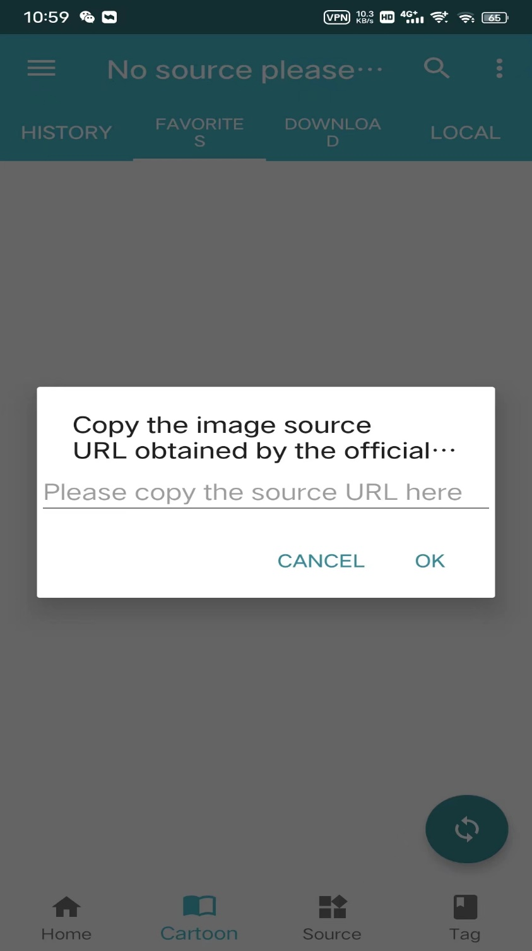

1. When it’s done and you can read freely.

